**Output**

1. <https://github.com/rvsp/typescript-oops/blob/master/Practice/Movie.md>

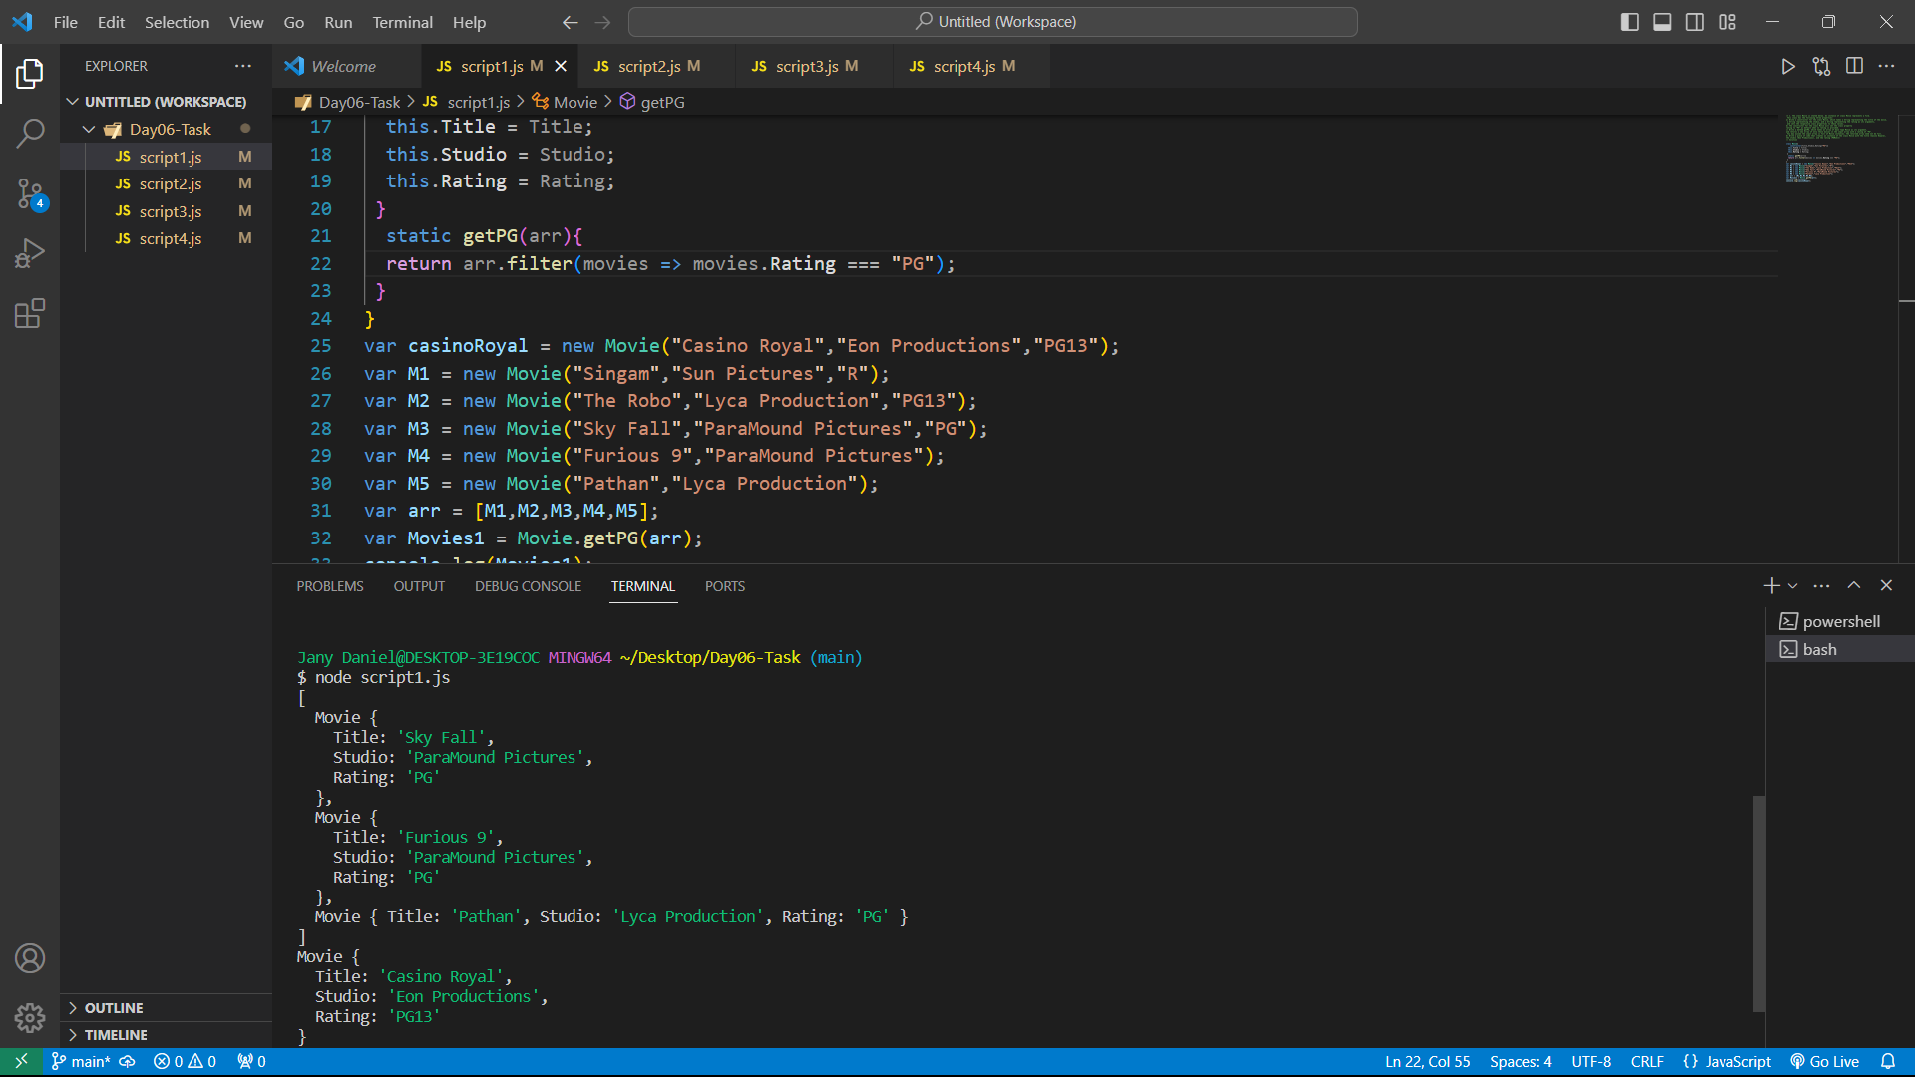

1. <https://github.com/rvsp/typescript-oops/blob/master/Practice/class-circle.md>

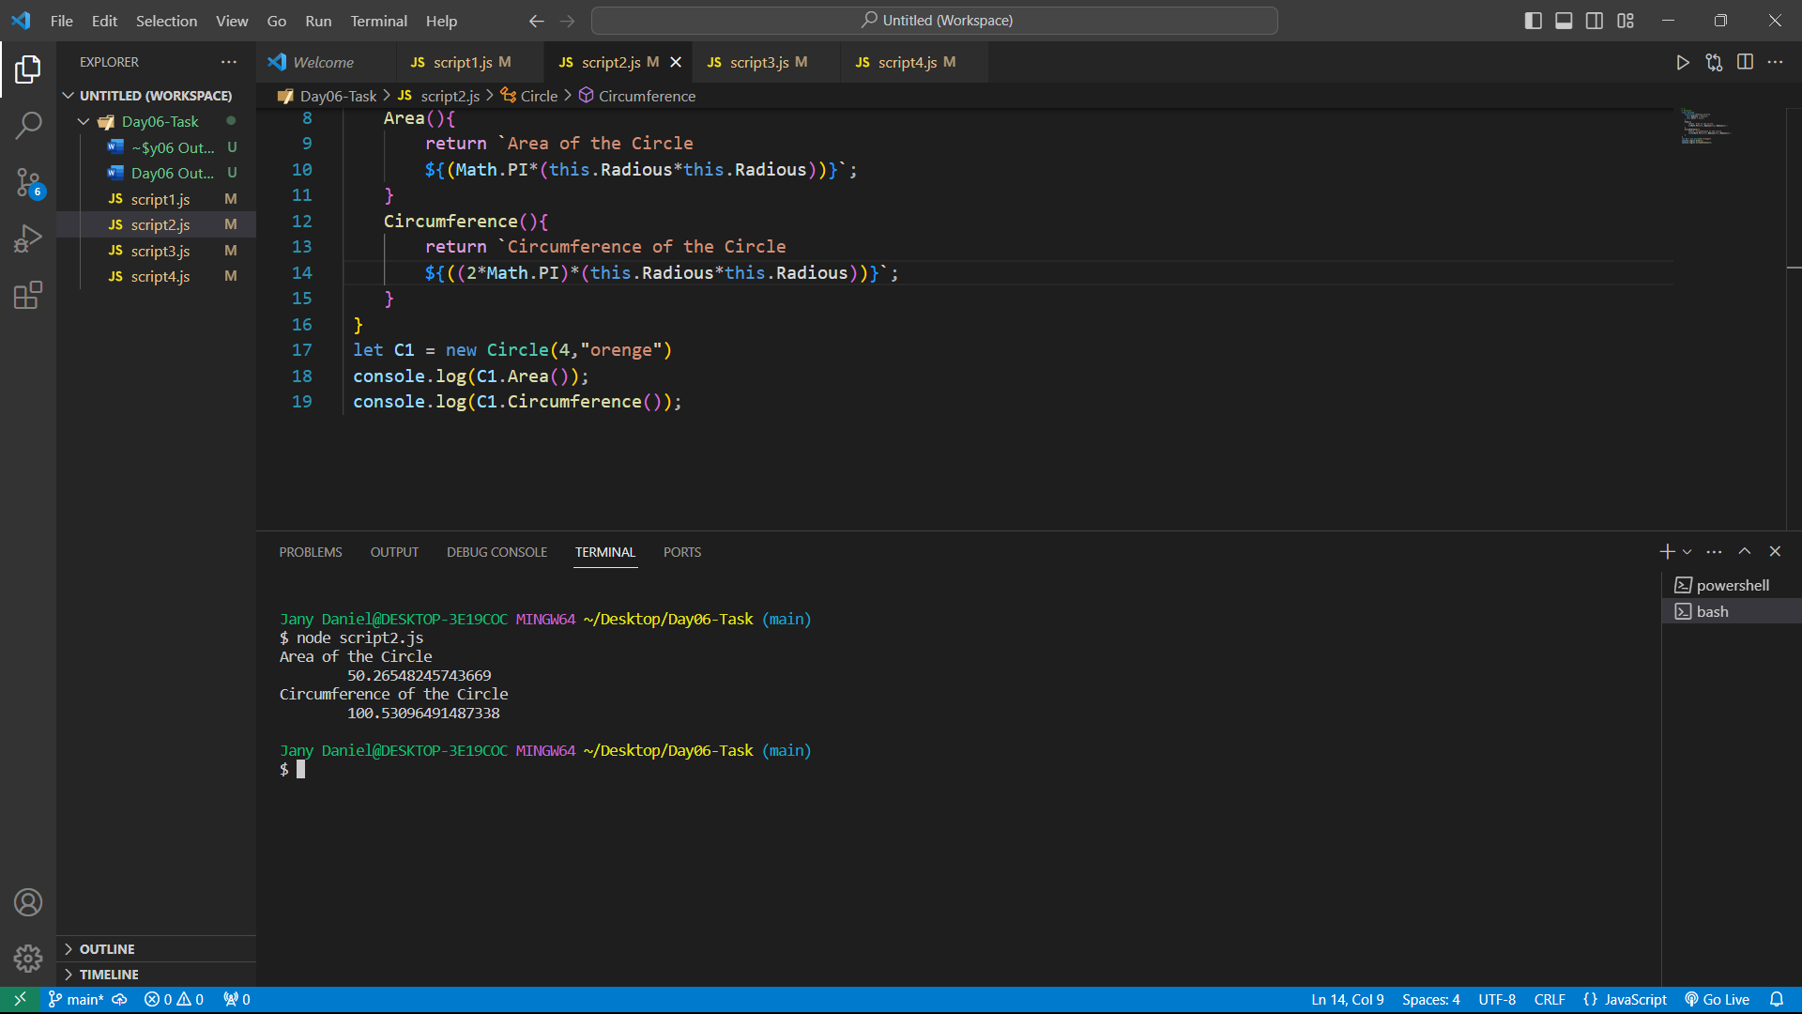

**3.) Write a “person” class to hold all the details.**

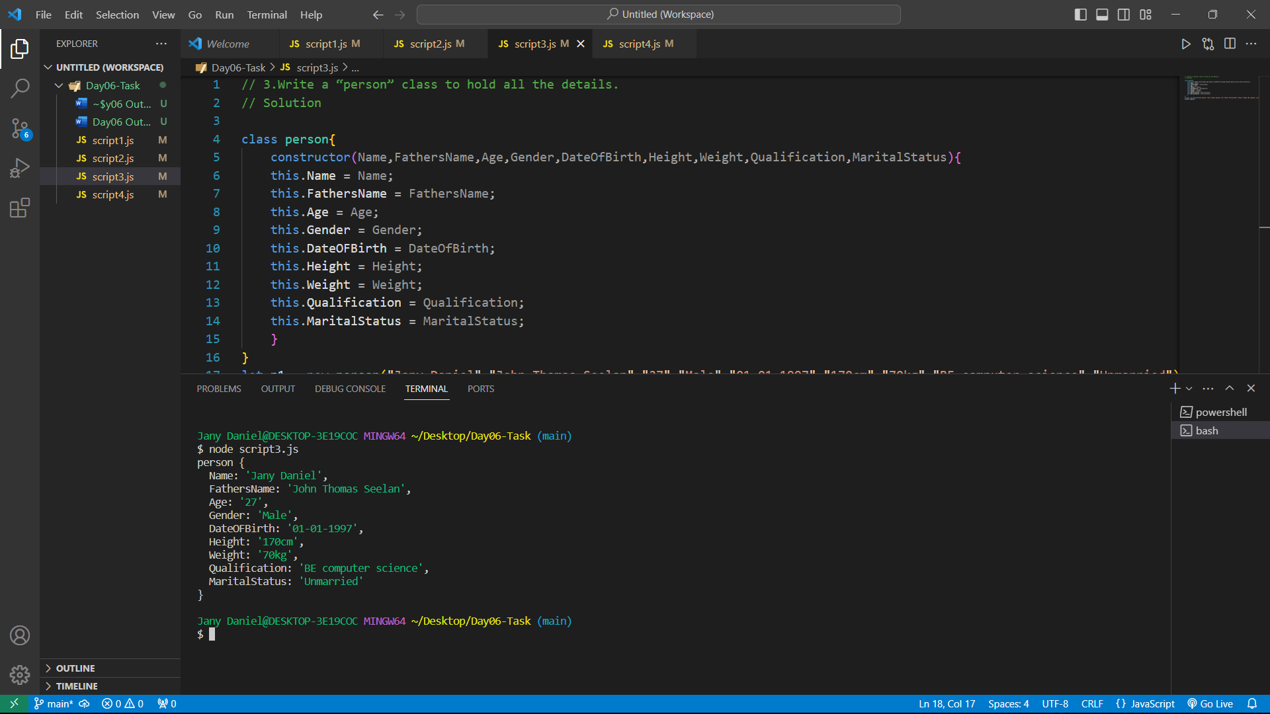

**4.) write a class to calculate the Uber price**

